**Introduction**

In this class activity, we explored the process of generating hash values for both weak and strong passwords using various hashing algorithms. We used the online tool to generate hash values and then attempted to crack these hashes using online crackers like, Crack Station.

**Steps Performed**

1. **Generating Hash Values:**

Used the password 1234# (weak password) and generated hash values using the following algorithms along with the hash values they generated:

* + - MD5: F97223DDDF692DFD903332BBEC69D407
    - SHA1: 4A413D247AB68EF153B2EE18855F82D38EDD57C0
    - SHA256: 9634B18AF2C07DBEEA71ABF88E654381B59685A5626695DA53C577C3F74B82A8
    - SHA512: CAF79E4C6F460A99D443F5986E8F2D42EE9459CEB39120EE1BD9F10A38F2492B5FFE6A3AFDF823709B7ADCB82A4C05AB77C28BD45DAFC764CBE38E22E6F10B20

1. **Observations on Hash Sizes:**

**MD5:** Produces a 32-character hash.

**SHA1:** Produces a 40-character hash.

**SHA256:** Produces a 64-character hash.

**SHA512:** Produces a 128-character hash.

The size of the hash value increases with the complexity of the hashing algorithm.

1. **Cracking the Hashes:**

Attempted to crack the hash values using online crackers.

**Simple Password (1234#):**

* + - Successfully cracked the hashes generated by MD5, SHA1, SHA256, and SHA512 as shown in the screenshots below.

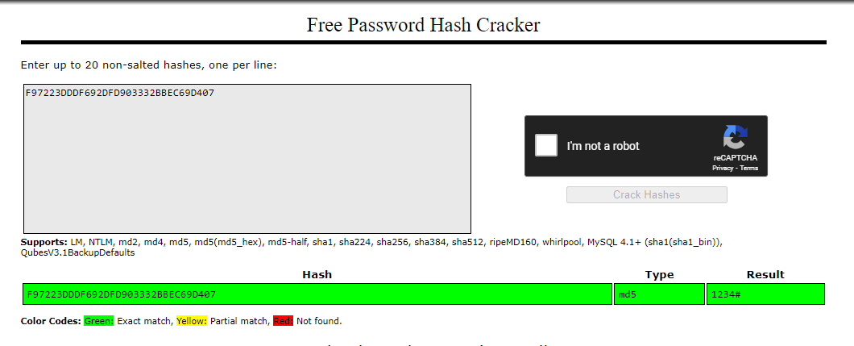

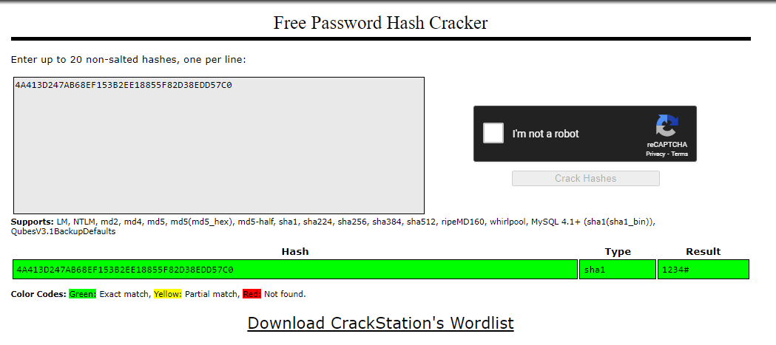

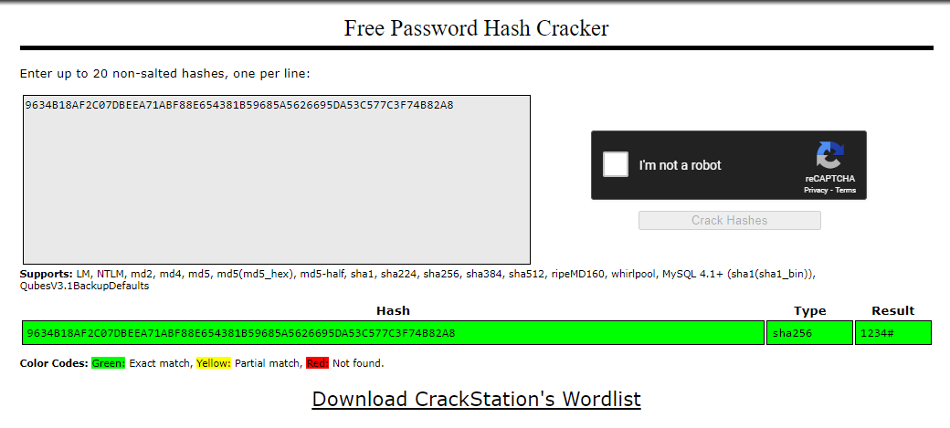

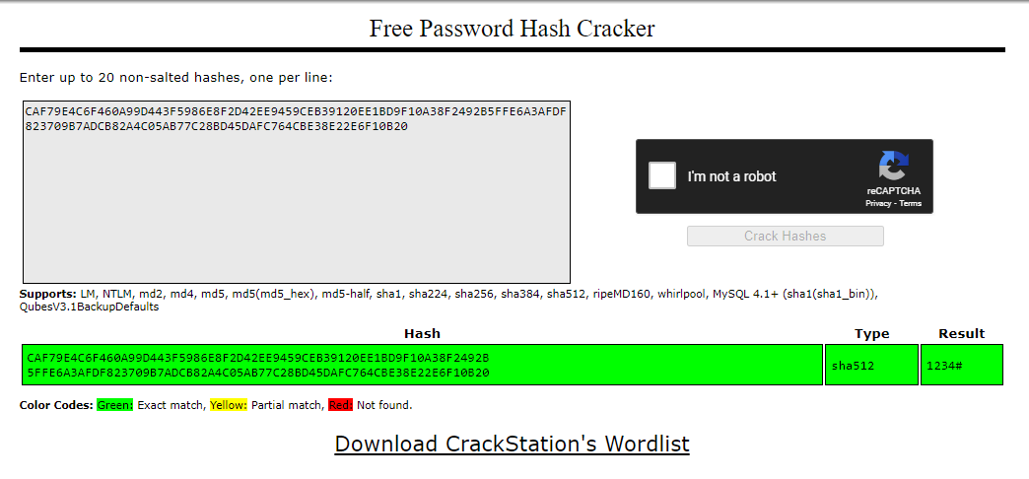

**Complex Passwords** (e.g., #a1b2C3D4):

When the password started with a letter or special symbol, none of the hash values for MD5, SHA1, SHA256, and SHA512 were successfully cracked.

Increasing the length of the password also resulted in the hashes remaining uncracked.

See the screenshot below

MD5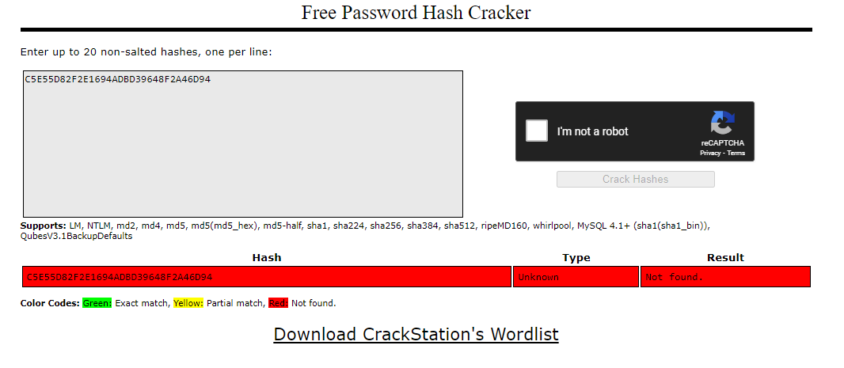

SHA1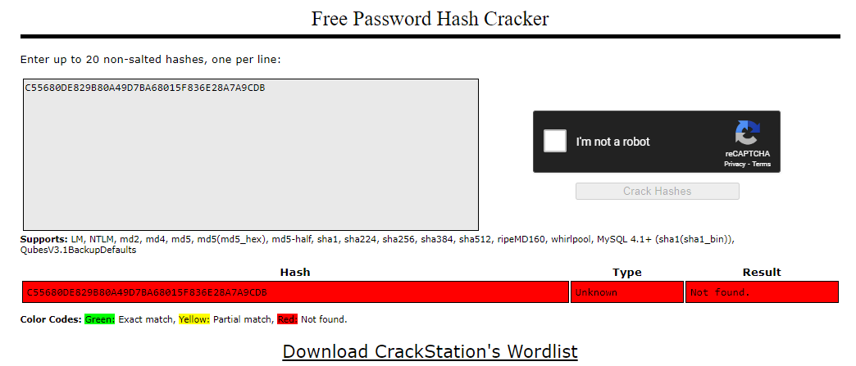

SHA256

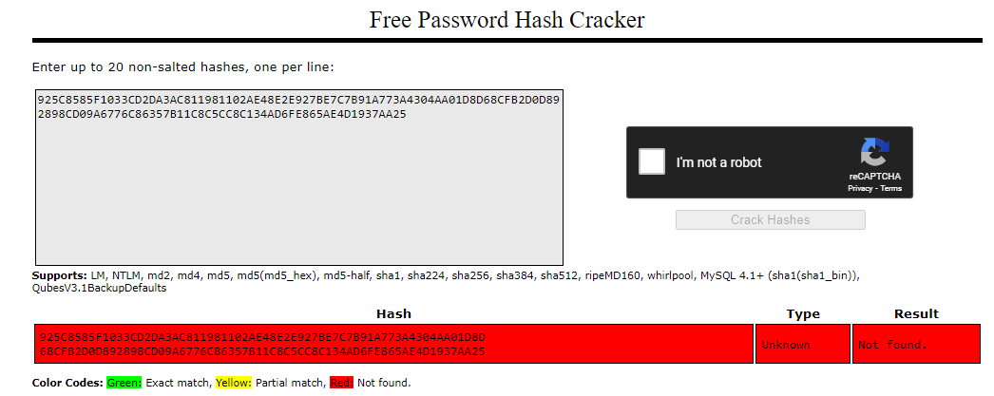

SHA512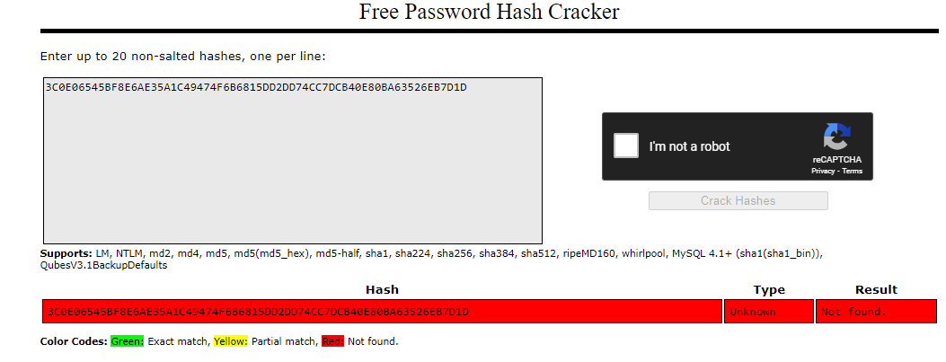

**Conclusion**

The activity demonstrated the following key points:

1. **Hash Value Sizes:** The size of hash values increases with the complexity of the hashing algorithm. MD5 generates the smallest hash, while SHA512 generates the largest.
2. **Crackability of Weak Passwords:** Weak passwords (e.g., 1234#) are easily cracked regardless of the hashing algorithm used. This indicates that weak passwords do not provide sufficient security even when hashed.
3. **Effectiveness of Strong Passwords:** Stronger passwords that start with letters or special symbols, or are of increased length, significantly reduce the likelihood of successful hash cracking. None of the hashes for complex passwords were cracked in this activity, highlighting the importance of using strong, complex passwords for security.

This activity underscores the importance of selecting strong passwords and using robust hashing algorithms to ensure data security.